PROGRAM NAME

Generic
MANUFACTURING READINESS LEVEL (MRL) ASSESSMENT PLAN

Insert LOGO

PROGRAM NAME
Generic
MANUFACTURING READINESS LEVEL (MRL) ASSESSMENT PLAN
Table of Contents
- PURPOSE………………………………………………………………………1
- OBJECTIVE……………………………………………………………………..1
- LOCATION AND SCHEDULE………………………………………………...1
- ORGANIZATION……………………………………………………………… 2
- RESPONSIBILITES…………………………………………………………….2
- METHODS AND PROCEDURES…………………………………………….4
Appendix A: MRL Assessment Daily Agenda ….…………………………….…A-1
Appendix B: MRL Definitions ………………….………………………………… B-1
Appendix C: MRL Matrix ………….……………………………………………… C-1
Appendix D: Technology Readiness Level (TRL) Definitions ……………...…D-1
Appendix E: Risk Assessment Process …………………………………………E-1
Appendix F: MRL Assessment Risk Sheet ………………………………..….…F-1
Appendix G: List of MRL Questions ……………………………………………..G-1

PURPOSE
The purpose of the MRL Assessment is to provide a formal assessment of the program’s current state of manufacturing maturity and readiness, identify manufacturing risks to the Government, and develop risk mitigation strategies. This review will assess the following:
- Stability of component design
- production planning
- proper facilities planning
- manufacturing processes development
- manufacturing infrastructure is in place
- proper quality control development
- viable qualified supplier base exists

OBJECTIVE
The ultimate goal of the MRL Assessment is to provide an accurate assessment of the state of the _______ program’s manufacturing readiness and to identify manufacturing risks that could impact the contractor’s ability to provide high quality product at rates necessary to meet fielding requirements. The MRL Assessment team will use Manufacturing Readiness Levels (MRLs) as the criteria for assessing the manufacturing readiness of the _____ Program across the contractors and subcontractors. The MRL Assessment team will follow the guidance and utilize the body of knowledge for assessing manufacturing risk provided in the Department of Defense website: http://www.dodmrl.org. Outputs of this assessment consist of briefings to the Program Manager (PM) immediately following the contractor site visits, and a Final MRL Assessment Report. The outputs of this assessment, including findings and improvement plans will not be construed as contractual direction or a change to the requirements contained in the Prime Contract.

LOCATIONS & SCHEDULE
This assessment will consist of site visits to the Prime contractor’s manufacturing facility, as well as site visits to major suppliers manufacturing facilities. The list of site visits and dates will be determined later. The manufacturing maturity and risks associated with all major components will be addressed in this assessment. The proposed supplier on-site visits will be chosen based on the criteria established in the MRL Deskbook.

Insert spreadsheet identify supplier, location, and date

ORGANIZATION
- The MRL Assessment Team will be a comprehensive multi-functional team and will be composed of personnel from the AMRDEC, ________ Project Office, identify other participating agencies. Defense Contract Management Agency (DCMA) personnel from each facility will be used according to their expertise to augment the MRL Assessment team. The MRL Assessment Team Members will be defined at a later date.
- The MRL Assessment Team Structure is identified in Table 1. The primary team member responsible for each Subthread of the MRL Matrix will be provided at a later date. The MRL Assessment Team structure will remain flexible in order to allow for the optimum team composition with respect to the supplier/subassembly being evaluated.

Table 1 – MRL Assessment Team Structure
Team Leader: _______, AMRDEC
Deputy: _______
Thread | Sub Thread | Name | Organization
Technology & Industrial Base | Technology Trans to Prod
Technology & Industrial Base | Mfg Technology Development
Design | Producibility Program
Design | Design Maturity
Cost & Funding | Production Cost Knowledge
Cost & Funding | Cost Analysis
Cost & Funding | Manufacturing Investment Budget
Materials | Maturity
Materials | Availability
Materials | Supply Chain Management
Materials | Special Handling
Process Capability & Control | Modeling & Simulation
Process Capability & Control | Mfg Process Maturity
Process Capability & Control | Process Yields & Rates
Quality Management | Quality Program
Mfg Personnel | Mfg Personnel
Facilities | Tooling/STE/SIE
Facilities | Facilities
Mfg Management | Mfg Planning & Scheduling
Mfg Management | Materials Planning

RESPONSIBILITIES
- Team Leader.
- The team leader will be responsible for the overall preparation and operation of the team to ensure that functional areas are reviewed in accordance with the MRL Assessment objectives.
- The team leader will coordinate Contractor preparation to enable the team to access and evaluate Contractor data. The team leader has direct authority over all team members within the scope of the MRL Assessment.
- The team leader will be responsible for preparation of the MRL Assessment report and for presenting the risks and recommendations to the_______ Project Office, and AMRDEC management.
- Team Members.
  - Each team member is responsible for objectively assessing the manufacturing readiness level criteria (see Appendix C) and the associated level of risk in his/her assigned area in accordance with the procedures outlined by the team leader and provided in this MRL Assessment plan. Team members will be engaged in MRL Assessment activities before, during, and after the planned contractor site visits.
  - Team members are expected to utilize their experience, judgment, and knowledge of the _______ program in their functional areas to determine the appropriate topics to be addressed during the review.
  - Team members will keep adequate records to ensure that conclusions and/or recommendations are documented.
  - At the review, each team member will document all risks and associated risk handling recommendation utilizing the format in Appendix F. Each team member will brief the identified risk and mitigation plans in his/her functional area to Government and Contractor management at the end of the review.
  - Each team member will support the final briefing given to the ______ Project Office and AMRDEC management.
- Prime Contractor/Supplier.
- Designate a management focal point for overall planning and support of the MRL Assessment, to include the supplier site visits.
- Designate and make available key Prime and Supplier personnel during each site visit.
- Perform adequate preparation by reviewing and being prepared to address the Questions identified in Appendix G. Also provide requested data in advance of the assessment such as quality management plans, process flows, value stream maps, etc.
- Make all information supporting the Questions in Appendix G, production planning, execution, and scheduling available for review during each site visit.
- Provide an initial presentation to the MRL Assessment team that addresses system configuration, program management, production planning, preparations, schedules, process flows, supply chain, milestones, and key personnel.
  - Provide administrative support, phone and Internet access, rooms for the splinter group sessions, and working space for the MRL Assessment team at each site.
  - Support and provide follow-up actions on all identified risks from the MRL Assessment in order to meet closure and/ or resolution by the date identified in the risk mitigation strategy.

METHODS AND PROCEDURES
The following methods and procedures will be in effect for the MRL Assessment:
- The MRL Assessment team will perform a site visit at the Prime Contractor and selected Supplier facilities.
- The Government team leader will work with Contractor MRL Assessment point of contact to ensure that all plans and schedules necessary to support the assessment have been coordinated.
- The Prime Contractor and Suppliers will perform adequate preparation by reviewing and being prepared to address the Questions identified in Appendix G. All information supporting the Questions in Appendix G, production planning, execution, and scheduling shall be made available for review during each site visit.
- Appendix A outlines a typical daily agenda for the MRL Assessment at each facility. An initial meeting will be held upon the arrival of the MRL Assessment team which consists of the following:
  - The Government MRL Assessment team will provide an introduction briefing to the Contractor on the purpose, structure, and objectives of the review.
  - The Contractor shall provide a presentation on the evolution and overall status of the ______ program, including system configuration, program management, production planning, preparations, schedules, process flows, supply chain, milestones, and key personnel. The presentation from the Contractor should not exceed two (2) hours in duration.
  - A facility tour and company overview will also be provided. The tour should not exceed one (1) hour in duration.
- Splinter group sessions will be held to address the functional areas of the review (see table 1). During these sessions, team members will interview key Contractor personnel and review all data and documentation related to production and manufacturing. The information discussed between functional counterparts in these sessions will form the basis of the assessment of the team and the completion of the evaluation matrix. Team members will keep adequate records to ensure that conclusions and/or recommendations are supportable.
- MRL Criteria
  - The MRL Assessment team will use MRLs as the criteria for assessing the manufacturing maturity and readiness of the _____ Program across the contractors and suppliers. The MRL Assessment team will follow the guidance and utilize the body of knowledge for assessing manufacturing risk provided in the Department of Defense website: http://www.dodmrl.org.
  - The target rating is MRL 8. The MRL Definitions are provided in Appendix B.
  - The team members will utilize the MRL Matrix (Appendix C), MRL Questions (Appendix G), and the Risk Assessment Process (Appendix E) to identify and assess manufacturing risks. The risk and recommendation will be documented utilizing the format in Appendix F.
  - Technology Readiness Levels (TRLs) identified in the “Technology & IB” thread of the MRL Criteria Matrix are referenced in Appendix D.
- Government-only team meetings will be held at the conclusion of each day to discuss progress, risks, and recommendations. The Government team leader will then meet with the Contractor team leader to provide a status report and resolve any issues.
- An exit briefing will be presented to the Contractor by the MRL Assessment Team prior to departure. The briefing will summarize the risks and recommendations of the MRL Assessment Team. (Note: this exit briefing represents a preliminary assessment and can be modified in the Final Report based on additional information).
- A briefing will be provided to the Program Manager at the conclusion of all the site visits. All risks and recommendations from the MRL Assessment will be documented in the MRL Assessment Report. The Final Report will be completed within 30 days after the completion of the MRL Assessment.

Appendix A
MRL Assessment Daily Agenda
MRL Assessment
Sample Daily Agenda

Day 1
 | 8:00 | - | 8:15 | Welcome | All
 | 8:15 | - | 8:30 | Gov't MRL Overview | Government Lead
 | 8:30 | - | 10:30 | Contractor Overview | Contractor Lead
 | 10:30 | - | 11:30 | Site Tour | All
 | 11:30 | - | 12:30 | Lunch | All
 | 12:30 | - | 16:30 | Splinter Group Sessions | All
 | 16:30 | - | 17:00 | Government Meeting | Government
Day 2
 | 8:00 | - | 11:00 | Splinter Group Sessions | All
 | 11:00 | - | 12:00 | Lunch | All
 | 12:00 | - | 15:00 | Government Meeting | Government
 | 15:00 | - | 16:00 | Exit Briefing | Government Lead
 | 16:00 | - |  | Adjourn

Notes:
- All times local
- Assumes 2 days for review
- Agenda can be adjusted as necessary

Appendix B

Manufacturing Readiness

Level (MRL) Definitions

DoD Manufacturing Readiness Level Definitions 2010

MRL | Definition | Description
1 | Basic Manufacturing Implications Identified. | This is the lowest level of manufacturing readiness. The focus is to address manufacturing shortfalls and opportunities needed to achieve program objectives. Basic research (i.e., funded by budget activity) begins in the form of studies.
2 | Manufacturing Concepts  Identified. | This level is characterized by describing the application of new manufacturing concepts. Applied research (i.e., funded by budget activity 6.2) translates basic research into solutions for broadly defined military needs. Typically this level of readiness in the S&T environment includes identification, paper studies and analysis of material and process approaches. An understanding of manufacturing feasibility and risk is emerging.
3 | Manufacturing Proof of Concept Developed. | This level begins the validation of the manufacturing concepts through analytical or laboratory experiments. This level of readiness is typical of technologies in the S&T funding categories of Applied Research and Advanced Development (i.e., funded by budget activity 6.3). Materials and/or processes have been characterized for manufacturability and availability but further evaluation and demonstration is required. Experimental hardware models have been developed in a laboratory environment that may possess limited functionality.
4 | Capability to produce the technology in a laboratory environment. | This level of readiness is typical for S&T Programs in the budget activity 6.2 and 6.3 categories and acts as an exit criterion for the Materiel Solution Analysis (MSA) Phase approaching a Milestone A decision. Technologies should have matured to at least TRL 4. This level indicates that the technologies are ready for the Technology Development Phase of acquisition. At this point, required investments, such as manufacturing technology development, have been identified. Processes to ensure manufacturability, producibility, and quality are in place and are sufficient to produce technology demonstrators. Manufacturing risks have been identified for building prototypes and mitigation plans are in place. Target cost objectives have been established and manufacturing cost drivers have been identified. Producibility assessments of design concepts have been completed. Key design performance parameters have been identified as well as any special tooling, facilities, material handling and skills required.
5 | Capability to produce prototype components in a production relevant environment. | This level of maturity is typical of the mid-point in the Technology Development Phase of acquisition, or in the case of key technologies, near the mid-point of an Advanced Technology Demonstration (ATD) project. Technologies should have matured to at least TRL 5. The industrial base has been assessed to identify potential manufacturing sources. A manufacturing strategy has been refined and integrated with the risk management plan. Identification of enabling/critical technologies and components is complete. Prototype materials, tooling and test equipment, as well as personnel skills have been demonstrated on components in a production relevant environment, but many manufacturing processes and procedures are still in development. Manufacturing technology development efforts have been initiated or are ongoing. Producibility assessments of key technologies and components are ongoing. A cost model has been constructed to assess projected manufacturing cost.
6 | Capability to produce a prototype system or subsystem in a production relevant environment. | This MRL is associated with readiness for a Milestone B decision to initiate an acquisition program by entering into the Engineering and Manufacturing Development (EMD) Phase of acquisition. Technologies should have matured to at least TRL 6. It is normally seen as the level of manufacturing readiness that denotes completion of S&T development and acceptance into a preliminary system design. An initial manufacturing approach has been developed. The majority of manufacturing processes have been defined and characterized, but there are still significant engineering and/or design changes in the system itself. However, preliminary design of critical components has been completed and producibility assessments of key technologies are complete. Prototype materials, tooling and test equipment, as well as personnel skills have been demonstrated on systems and/or subsystems in a production relevant environment. A cost analysis has been performed to assess projected manufacturing cost versus target cost objectives and the program has in place appropriate risk reduction to achieve cost requirements or establish a new baseline. This analysis should include design trades. Producibility considerations have shaped system development plans. The Industrial Capabilities Assessment (ICA) for Milestone B has been completed. Long-lead and key supply chain elements have been identified.
7 | Capability to produce systems, subsystems or components in a production representative environment. | This level of manufacturing readiness is typical for the mid-point of the Engineering and Manufacturing Development (EMD) Phase leading to the Post-CDR Assessment. Technologies should be on a path to achieve TRL 7. System detailed design activity is underway. Material specifications have been approved and materials are available to meet the planned pilot line build schedule. Manufacturing processes and procedures have been demonstrated in a production representative environment. Detailed producibility trade studies and risk assessments are underway. The cost model has been updated with detailed designs, rolled up to system level, and tracked against allocated targets. Unit cost reduction efforts have been prioritized and are underway. The supply chain and supplier quality assurance have been assessed and long-lead procurement plans are in place. Production tooling and test equipment design and development have been initiated.
8 | Pilot line capability demonstrated. Ready to begin low rate production. | This level is associated with readiness for a Milestone C decision, and entry into Low rate Initial Production (LRIP). Technologies should have matured to at least TRL 7. Detailed system design is essentially complete and sufficiently stable to enter low rate production. All materials are available to meet the planned low rate production schedule. Manufacturing and quality processes and procedures have been proven in a pilot line environment and are under control and ready for low rate production. Known producibility risks pose no significant challenges for low rate production. The engineering cost model is driven by detailed design and has been validated with actual data. The Industrial Capabilities Assessment for Milestone C has been completed and shows that the supply chain is established and stable.
9 | Low Rate Production demonstrated. Capability in place to begin Full Rate Production. | At this level, the system, component or item has been previously produced, is in production, or has successfully achieved low rate initial production. Technologies should have matured to TRL 9. This level of readiness is normally associated with readiness for entry into Full Rate Production (FRP). All systems engineering/design requirements should have been met such that there are minimal system changes. Major system design features are stable and have been proven in test and evaluation. Materials are available to meet planned rate production schedules. Manufacturing process capability in a low rate production environment is at an appropriate quality level to meet design key characteristic tolerances. Production risk monitoring is ongoing. LRIP cost targets have been met, and learning curves have been analyzed with actual data. The cost model has been developed for FRP environment and reflects the impact of continuous improvement.
10 | Full Rate Production demonstrated and lean production practices in place. | This is the highest level of production readiness. Technologies should have matured to TRL 9. This level of manufacturing is normally associated with the Production or Sustainment phases of the acquisition life cycle. Engineering/design changes are few and generally limited to quality and cost improvements. System, components or items are in full rate production and meet all engineering, performance, quality and reliability requirements. Manufacturing process capability is at the appropriate quality level. All materials, tooling, inspection and test equipment, facilities and manpower are in place and have met full rate production requirements. Rate production unit costs meet goals, and funding is sufficient for production at required rates. Lean practices are well established and continuous process improvements are ongoing.

Definitions of Terms Found in Manufacturing Readiness Level Definitions
Production relevant environment – An environment normally found during MRL 5 and 6 that contains key elements of production realism not normally found in the laboratory environment (e.g. uses production personnel, materials or equipment or tooling, or process steps, or work instructions, stated cycle time, etc.). May occur in a laboratory or model shop if key elements or production realism are added.
Production representative environment – An environment normally found during MRL 7 (probably on the manufacturing floor) that contains most of the key elements (tooling, equipment, temperature, cleanliness, lighting, personnel skill levels, materials, work instructions, etc) that will be present in the shop floor production areas where low rate production will eventually take place.
Pilot line environment – An environment normally found during MRL 8 in a manufacturing floor production area that incorporates all of the key elements (equipment, personnel skill levels, materials, components, work instructions, tooling, etc.) required to produce production configuration items, subsystems or systems that meet design requirements in low rate production. To the maximum extent practical, the pilot line should utilize rate production processes.
Manufacturability – The characteristics considered in the design cycle that focus on process capabilities, machine or facility flexibility, and the overall ability to consistently produce at the required level of cost and quality. Activities can include some or all of the following activities:
- Design for commonality and standardization- fewer parts
- Perform comprehensive Technology Assessment, including commercial industrial applications and the supplier base
- Design for Multi-Use and Dual-Use applications
- Design for modularity and plug compatible interface/integration
- Design for flexibility, adaptability, and “robust design”
- Utilize reliable processes and materials
Producibility – Is the capability of an item to be produced, including some or all of the following activities:
- Design to specific Cp-CpK process control parameters- six sigma
- Perform material characterization analysis
- Perform variability reduction analysis- Taguchi, DOE
- Develop critical materials and processes before selecting product design
- Utilize pervasive modeling & simulation for product and process design tradeoffs
- Design and deployment of closed-loop process-control on critical items

Appendix C

Manufacturing Readiness

Level (MRL) Matrix

Insert the latest version of the Matrix

Version 10.4 | 3-Nov-09
DoD Manufacturing Readiness Levels (MRLs)
Acquisition Phase |  |  |  | Engineering & Mfg Development (EMD) |  |  |  | Low-Rate Initial Production (LRIP)
Technical Reviews |  |  | PDR | CDR |  | PRR/SVR |  | PCA
Thread | Sub-Thread |  | MRL 6 | MRL 7 |  | MRL 8 |  | MRL 9
 | Technology  Maturity |  | Should be assessed at TRL 6. | Should be assessed at TRL 7 |  | Should be assessed at TRL 7. |  | Should be assessed at TRL 9.
A- Technology and Industrial Base | A.1 - Technology Transition to Production |  | Industrial Capability Assessment (ICA) for MS B has been completed. Industrial capability in place to support mfg of development articles. Plans to minimize sole/foreign sources complete. Need for sole/single/foreign sources justified. Potential alternative sources identified. | Industrial capability to support production has been analyzed. Sole/single/foreign sources stability is assessed/monitored. Developing potential alternate sources as necessary. |  | Industrial Capability Assessment (ICA) for MS C has been completed. Industrial capability is in place to support LRIP. Sources are available, multi-sourcing where cost-effective or necessary to mitigate risk. |  | Industrial capability is in place to support start of FRP.
 | A.2 - Manufacturing Technology Development |  | Manufacturing technology efforts continuing. Required manufacturing technology development solutions demonstrated in a production relevant environment. | Manufacturing technology efforts continuing. Required manufacturing technology development solutions demonstrated in a production representative environment. |  | Primary manufacturing technology efforts concluding, and some improvement efforts continuing. Required manufacturing technology solutions validated on a pilot line. |  | Manufacturing technology process improvements efforts initiated for FRP.
B - Design | B.1 - Producibility Program |  | Producibility assessments and producibility trade studies (performance vs. producibility) of key technologies/components completed. Results used to shape Acquisition Strategy, Systems Engineering Plan (SEP), Manufacturing and Producibility plans, and planning for EMD or technology insertion programs. Preliminary design choices assessed against manufacturing processes and industrial base capability constraints. Producibility enhancement efforts (e.g. Design For Mfg Assembly (DFX)) initiated. | Detailed producibility trade studies using knowledge of key design characteristics and related manufacturing process capability completed. Producibility enhancement efforts (e.g. DFX) ongoing for optimized integrated system. Manufacturing processes re-assessed as needed for capability to test and verify potential influence on Operations & Support. |  | Producibility improvements implemented on system. Known producibility issues have been resolved and pose no significant risk for LRIP. |  | Prior producibility improvements analyzed for effectiveness during LRIP. Producibility issues/risks discovered in LRIP have been mitigated and pose no significant risk for FRP.
 | B.2 - Design Maturity |  | System allocated baseline established; system and subsystem preliminary design sufficient for EMD. All enabling/critical technologies/components have been demonstrated. Preliminary design KCs defined. | Product requirements and features are well enough defined to support critical design review, even though design change traffic may be significant. All product data essential for component manufacturing has been released. Potential KC risk issues have been identified and mitigation plan is in place. |  | Detailed design of product features and interfaces is complete. All product data essential for system manufacturing has been released. Design change traffic does not significantly impact LRIP. Key Characteristics are attainable based upon pilot line demonstrations. |  | Major product design features and configuration are stable. System design has been validated through operational testing of LRIP items. Physical Configuration Audit (PCA) or equivalent complete as necessary. Design change traffic is limited. All KCs are controlled in LRIP to appropriate quality levels.
C - Cost & Funding | C.1 - Production Cost Knowledge (Cost modeling) |  | Cost model updated with design requirements, material specifications, tolerances, integrated master schedule, results of system/subsystem simulations and production relevant prototype demonstrations. | Cost model updated with the results of systems/sub-systems produced in a production representative environment, production plant layout and design, and obsolescence solutions. |  | Cost models updated with results of pilot line build. |  | FRP cost model updated with result of LRIP build.
 | C.2 - Cost Analysis |  | Costs analyzed using prototype system/sub-system actuals to ensure target costs are achievable. Allocate cost targets to subsystems. Cost reduction and avoidance strategies developed. | Manufacturing costs rolled up to system/sub-system level and tracked against targets. Detailed trade studies and engineering change requests supported by cost estimates. Cost reduction and avoidance strategies underway. |  | Costs analyzed using pilot line actuals to ensure target costs are achievable. Manufacturing cost analysis supports proposed changes to requirements or configuration. Cost reduction initiatives ongoing. |  | LRIP cost goals met and learning curve analyzed with actual data. Cost reduction initiatives ongoing. Touch labor efficiency analyzed to meet production rates and elements of inefficiency are identified with plans in place for reduction.
 | C.3 - Manufacturing Investment Budget |  | Program has reasonable budget estimate for reaching MRL 8 by MS C. Estimate includes capital investment for production-representative equipment by CDR and pilot line equipment by MS C. All outstanding MRL 6 risk areas understood with approved mitigation plans in place. | Program has updated budget estimate for reaching MRL 8 by MS C. All outstanding MRL 7 risk areas understood with approved mitigation plans in place. |  | Program has reasonable budget estimate for reaching MRL 9 by the FRP decision point. Estimate includes investment for LRIP and FRP. All outstanding MRL 8 risk areas understood with approved mitigation plans in place. |  | Program has reasonable budget estimate for FRP. All outstanding MRL 9 risk areas understood with approved mitigation plans in place.
D - Materials (Raw Materials, Components, Sub-assemblies and Sub-systems) | D.1 - Maturity |  | Material maturity verified through technology demonstration articles. Preliminary material specifications in place and material properties have been adequately characterized. | Material maturity sufficient for pilot line build. Material specifications approved. |  | Materials proven and validated during EMD as adequate to support LRIP. Material specification stable. |  | Material is proven and controlled to specification in LRIP.
 | D.2 - Availability |  | Availability issues addressed to meet EMD build. Long lead items identified. Potential obsolescence issues identified. | Availability issues addressed to meet EMD builds. Long lead procurement identified/planned for LRIP. Obsolescence plan in place. |  | Long lead procurement initiated for LRIP. Availability issues pose no significant risk for LRIP. |  | Long lead procurement initiated for FRP. Availability issues pose no significant risk for FRP.
 | D.3 - Supply Chain Management |  | Supply chain plans in place (e.g. teaming agreements, etc.) leading to an EMD contract award. | Effective supply chain management process in place. Assessment of critical first tier supply chain completed. |  | Supply chain adequate to support LRIP. Assessment of critical second and lower tier supply chain completed. |  | Supply chain is stable and adequate to support FRP. Long term agreements in place where practical.
 | D.4 - Special Handling  (i.e. Government Furnished Property (GFP), shelf life, security, hazardous materials, storage environment, etc.) |  | Special handling procedures applied in production relevant environment. Plans to address special handling requirement gaps complete. | Special handling procedures applied in production representative environment. Special handling procedures developed and annotated on work instructions. |  | Special handling procedures applied in pilot line environment. Special handling procedures demonstrated in EMD or Technology Insertion Programs. Special handling issues pose no significant risk for LRIP. All work instructions contain special handling provisions as required. |  | Special handling procedures applied in LRIP environment. Special handling procedures demonstrated in LRIP. Special handling issues pose no significant risk for FRP.
E - -Process Capability & Control | E.1 - Modeling & Simulation (Product & Process) |  | Initial simulation models developed at the sub-system or system level. | Simulation models used to determine system constraints and identify improvement opportunities. |  | Simulation models verified by pilot line build. Results used to improve process and determine that LRIP requirements can be met. |  | Simulation model verified by LRIP build, assists in management of LRIP, and determines that FRP requirements can be met.
 | E.2 - Manufacturing Process Maturity |  | Manufacturing processes demonstrated in production relevant environment. Begin collecting or estimating process capability data from prototype build. | Manufacturing processes demonstrated in a production representative environment. Continue collecting or estimating process capability data. |  | Manufacturing processes verified for LRIP on a pilot line. Process Capability data from pilot line meets target. |  | Manufacturing processes are stable, adequately controlled, capable, and have achieved program LRIP objectives. Variability experiments conducted to show FRP impact and potential for continuous improvement.
 | E.3 - Process Yields and Rates |  | Yields and rates from production relevant environment evaluated against targets and the results feed improvement plan. | Yields and rates from production representative environment evaluated against pilot line targets and the results feed improvement plans. |  | Pilot line targets achieved. Yields and rates required to begin LRIP verified using pilot line articles. Improvement plans ongoing and updated. |  | LRIP yield and rate targets achieved. Yield improvements on-going.
F - Quality Management | F.1 - Quality Management including Supplier Quality. |  | Initial quality plan and quality management system is in place. Quality risks and metrics have been identified. | Quality targets established. Demonstrate ability to collect and analyze quality data (process and system) in the production representative environment. |  | Quality targets demonstrated on pilot line. Continuous quality improvement on-going. Supplier products have completed qualification testing and first article inspection. Supplier products pass acceptance testing at a rate adequate to begin LRIP. |  | Quality targets verified on LRIP line. Continuous quality improvement on-going . Supplier products pass acceptance testing at a rate adequate to transition to FRP.
G - Mfg Personnel | G.1 - Mfg Personnel |  | Mfg workforce skills available for production in a relevant environment. Identify resources (quantities and skill sets) and develop initial plans to achieve requirements for pilot line and production. | Mfg workforce resource requirements identified for pilot line. Plans developed to achieve pilot line requirements. Plans updated to achieve LRIP workforce requirements. Pilot line workforce trained in representative environment. |  | Mfg workforce resource requirements identified for LRIP. Plans developed to achieve LRIP requirements. Plans updated to achieve FRP workforce requirements. LRIP personnel trained on pilot line where possible. |  | LRIP personnel requirements met. Implement plan to achieve FRP workforce requirements.
H - Facilities | H.1 - Tooling / Special Test and Inspection Equipment (STE/SIE) |  | Prototype tooling and STE/SIE concepts demonstrated in production relevant environment. Production tooling and STE/SIE requirements developed. | Production tooling and STE/SIE design and development efforts underway. Mfg equipment maintenance strategy developed. |  | All tooling, test and inspection equipment proven on pilot line and requirements identified for LRIP. Mfg equipment maintenance demonstrated on pilot line. |  | All tooling, test and inspection equipment proven in LRIP and requirements identified for FRP. Mfg equipment maintenance schedule demonstrated.
 | H.2 - Facilities |  | Manufacturing facilities identified and plans developed to produce pilot line build. | Manufacturing facilities identified and plans developed to produce LRIP build. |  | Pilot line facilities demonstrated. Mfg facilities adequate to begin LRIP. Plans in place to support transition to FRP. |  | Mfg facilities in place and demonstrated in LRIP. Capacity plans adequate to support FRP.
I - Mfg Management | I.1 - Mfg Planning & Scheduling |  | Initial mfg approach developed. All system design related mfg events included in Integrated Master Plan/Schedule (IMP/S). Mfg risk mitigation approach for pilot line or technology insertion programs defined. | Initial mfg plan developed. Mfg planning required to achieve MRL 8 has been included in the IMP/S. Mfg risks integrated into risk mitigation plans. Develop initial work instructions. Effective production control system in place to support pilot line. |  | Mfg plan updated for LRIP. All key manufacturing risks are identified and assessed with approved mitigation plans in place. Work instructions finalized. Effective production control system in place to support LRIP. |  | Mfg plan updated for FRP. All manufacturing risks tracked and mitigated. Effective production control system in place to support FRP.
 | I.2 - Materials Planning |  | Most material decisions complete (make/buy), material risks identified and mitigation plans developed. Bill of Materials (BOM) initiated. | Make/Buy decisions and BOM complete for pilot line build. Material planning systems in place for pilot line build. |  | Make/Buy decisions and BOM complete to support LRIP. Material planning systems in place for LRIP build. |  | Make/Buy decisions and BOM complete to support FRP. Material planning systems in place for FRP.
Note: This Matrix can be tailored to meet the requirements of your specific program.
For explanation of Production Relevant Environment, Production Representative Environment, and Pilot Line Environment see the DoD MRL Deskbook.

Appendix D
Technology Readiness

Level (TRL) Definitions

TRL Definitions
TRL | Definition | Description
1 | Basic principles observed and reported. | Lowest level of technology readiness. Scientific research begins to be translated into applied research and development (R&D). Examples might include paper studies of a technology’s basic properties.
2 | Technology concept and/or application formulated. | Invention begins. Once basic principles are observed, practical applications can be invented. Applications are speculative, and there may be no proof or detailed analysis to support the assumptions. Examples are limited to analytic studies.
3 | Analytical and experimental critical function and/or characteristic proof of concept. | Active R&D is initiated. This includes analytical studies and laboratory studies to physically validate the analytical predictions of separate elements of the technology. Examples include components that are not yet integrated or representative.
4 | Component and/or breadboard validation in a laboratory environment. | Basic technological components are integrated to establish that they will work together. This is relatively “low fidelity” compared with the eventual system. Examples include integration of “ad hoc” hardware in the laboratory.
5 | Component and/or breadboard validation in a relevant environment. | Fidelity of breadboard technology increases significantly. The basic technological components are integrated with reasonably realistic supporting elements so they can be tested in a simulated environment. Examples include “high-fidelity” laboratory integration of components.
6 | System/subsystem model or prototype demonstration in a relevant environment. | Representative model or prototype system, which is well beyond that of TRL 5, is tested in a relevant environment. Represents a major step up in a technology’s demonstrated readiness. Examples include testing a prototype in a high-fidelity laboratory environment or in a simulated operational environment.
7 | System prototype demonstration in an operational environment. | Prototype near or at planned operational system. Represents a major step up from TRL 6 by requiring demonstration of an actual system prototype in an operational environment (e.g., in an aircraft, in a vehicle, or in space).
8 | Actual system completed and qualified through test and demonstration. | Technology has been proven to work in its final form and under expected conditions. In almost all cases, this TRL represents the end of true system development. Examples include developmental test and evaluation (DT&E) of the system in its intended weapon system to determine if it meets design specifications.
9 | Actual system proven through successful mission operations. | Actual application of the technology in its final form and under mission conditions, such as those encountered in operational test and evaluation (OT&E). Examples include using the system under operational mission conditions.
Technology Readiness Assessment (TRA) Deskbook (Jul 09)

Appendix E
Risk Assessment Process

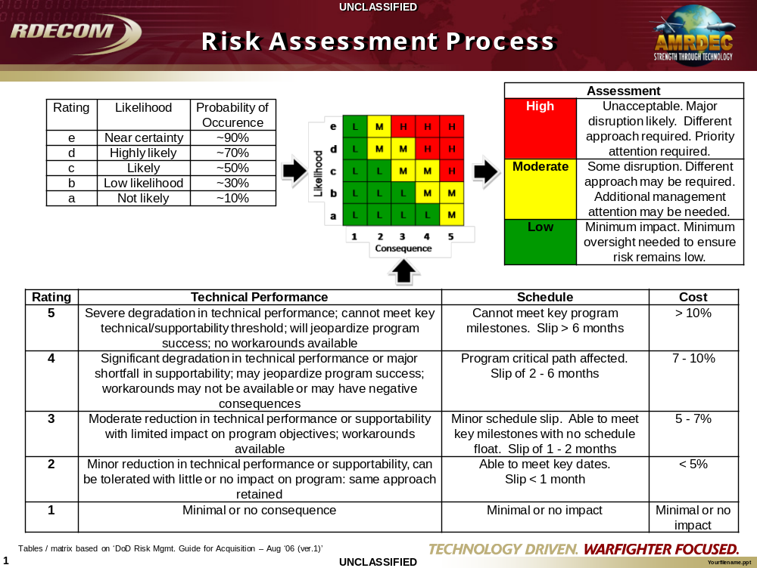

Appendix F
MRL Assessment Risk Sheet
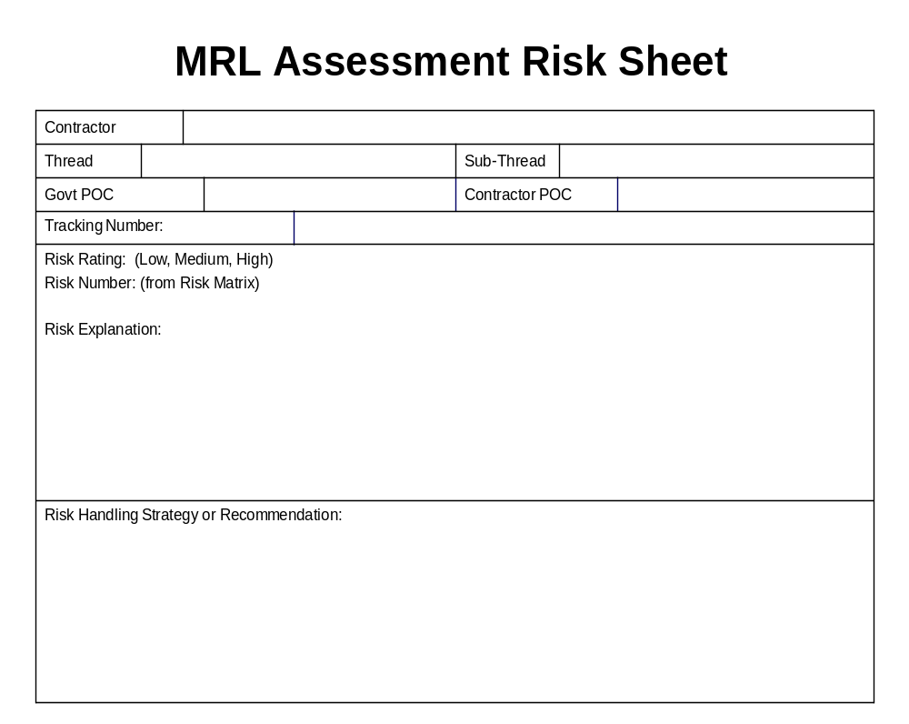

Appendix G
List of MRL Questions

Modify questions as necessary depending on Target MRL

MRL 8 Questions

Technology & Industrial Base
Technology Maturity
- Has the program attained a minimum TRL 7?
- Are all the technology barriers documented and are plans implemented to reduce risk?
- Have all manufacturing technology voids been eliminated?
Technology Transition to Production
- Have Industrial Base surveys been performed?
- Is the Industrial Base necessary to support this program available?
- Is the Industrial Capability Analysis (ICA) complete?
- Does the ICA address subcontractors, suppliers, and vendors?
- Have contingency plans been developed for Industrial Base issues?

Design
Producibility Program
- Has a Producibility Engineering & Planning (PEP) program been established?
- Is producibility part of the design process?
- Have Design for Manufacturing & Assembly (DFMA) or trade studies been conducted to identify producibility initiatives?
- Have these producibility initiatives been implemented into the design?
- Have these producibility initiatives been demonstrated on Pilot Line build?
- Is there an approach to utilize a Pilot Line or production representative build to verify the producibility of this design?
- Can this design be manufactured to meet the ramped up rates?
- Are all producibility and manufacturing activities incorporated into the Integrated Master Schedule (IMS)?

Design Maturity
- How many items of this design have been produced?
- Is the design considered stable and under control for the increased production rate?
- Has this design been qualified through test and demonstration?
- Has this technology been proven to work in its final form and under expected conditions?
- Have all physical and functional interfaces been clearly identified?
- Does the design meet all physical constraints such as size and weight?
- Are any changes proposed to Form, Fit, and Function that impact manufacturing (such as requiring new processes, materials, and/or manufacturing technology)?
- Are technical changes anticipated for this product in ramped up production? If so, what is the estimated number?
- How many will impact the performance and/or manufacturing processes of this product?
- Have Key Characteristics that affect performance been identified?
- Have Key Characteristics been evaluated to determine impact on producibility?
- Have tolerances for Key Characteristics been established?
- What special processes or procedures are used to control them?
- How are these Key Characteristics identified on the shop paperwork?
- Has Pilot Line build demonstrated that Key Characteristics can be met with current manufacturing processes?

Cost & Funding
Cost Analysis
- What is the corporate approach to implementing Design to Cost (DTC)?
- Have system level DTC goals been established?
- Have subsystem DTC goals been established?
- Have DTC evaluations been conducted?
- Have trade studies considered cost reduction options?
- Have these cost reductions options been incorporated?
- What is process for determining current estimates?
- Are DTC goals achievable?
- What is the management plan to achieve overall cost goals?
- Have potential future cost reduction initiatives been identified?
- What are the plans to implement further cost reduction initiatives?

Materials
Materials Maturity
- Have materials been used on similar programs in production?
- How long have current materials been in use?
- Are there any unique materials to the process or part?
- Is there a materials transition plan in place to identify and incorporate new materials?
- Have current materials been proven and validated on Pilot Line build?
- Are materials controlled in current process?
- Are all Material Specifications developed and stable?
- Have all material maturity issues been identified with mitigation plans developed?

Availability
- Are sources available and established for all material and components?
- Have all exotic/critical/hazardous materials been identified?
- Have all single/sole/foreign sources been identified, evaluated, and addressed for alternates?
- Has parts obsolescence been addressed?
- Defense Priorities & Allocations System (DPAS) flowed to all subcontractors/vendors?
- Have lead times been determined for all material and components?
- Has long lead procurement for the ramped up production been initiated?
- Are all material and components available to meet the increased production rates?
- Has a plan been developed to address all availability issues?

Supply Chain Management
- Has an adequate subcontractor/supplier management plan been established?
- Is the current supply chain stable?
- Have all subcontractor/supplier components been qualified?
- Is there a vendor rating system established?
- Has the contractor performed an assessment of 2nd tier suppliers?

Special Handling
- Has the contractor identified any special handling and/or storage requirements?
- Has handling equipment been specified for safe handling of tools and product?
- Are packing, handling and transport of major assembly procedures in place?
- Is any training associated with special handling and/or storage requirements necessary?
- Have special handling procedures been incorporated into manufacturing documentation?
- Have these procedures been demonstrated on Pilot Line build?

Process Capability & Control

Manufacturing Process Capability
- Have manufacturing processes been used on similar programs in production? How long?
- Are there any unique manufacturing processes required for this product?
- Have all critical processes been identified?
- Is there a transition plan in place to identify and incorporate new processes?
- Have current processes been proven and validated on Pilot Line build?
- Is process capability data being collected?
- How are manufacturing processes controlled?
- Does the program have a variation and variability reduction plan?
- Is there a means for shop personnel to make recommendations to management and quality for possible improvements?

Yields & Rates
- Is a system in place to collect and analyze yield data?
- What is your demonstrated first pass yield for each part number?
- Do you rework each part number to achieve 100% yield?
- How is rework accomplished (in-line, designated area)?
- Are rework procedures in place?
- What percentage of parts requires rework?
- Have all yield issues been identified?
- Have mitigation plans been developed?
- Has yield data been collected on Pilot Line build?
- Have yield goals been established for the increased production rates and are they achievable?
- Are process changes required to improve yield to meet the ramped up quantities?

Quality Management
Quality Program
- Is company Quality Management System in place and current with ANSI & ISO requirements?
- Are major suppliers Quality Management Systems in place?
- Have provisions been developed for items such as Statistical Process Control (SPC), Environmental Stress Screening (ESS), Failure Reporting and Corrective Action System (FRACAS), inspection procedures, test procedures, variability reduction program, etc.
- Have Quality Assurance Provisions (QAPs) been established? Are these identified on drawings?
- Is a supplier management program in place?
- Is there a vendor rating system?
- Have QA provisions been demonstrated on Pilot Line build?
- Are DCMA resources integrated in program?
- Has a First Article Inspection (FAI) been performed and documented?
- Does Quality Control approve change notices?
- Is there an approved supplier list and have QC, FRACAS requirements been flowed down to suppliers?
- Is there a documented calibration approach? Are cal due dates identified on all equipment? Is all equipment compliant with cal due dates?
- Is there a documented non-conforming material review process?

Manufacturing Personnel
Manufacturing Personnel
- Have the Manufacturing workforce requirements for ramped up production been identified (manpower estimates)?
- Is an adequate workforce (with necessary skills) available and stable?
- What special skills are needed in the production process and where are they needed?
- Have special skills necessary for this product been demonstrated on Pilot Line build?
- Has a training program been established for the special skills mentioned above, and what record exists of their training and certification?
- Is recurrent training or recertification required of employees with these special skills?
- Is there a scarcity of employees with these special skills which would impact production?
- Are there any initiatives in place for “cross training” employees to become proficient in different special skills?

Facilities
Tooling/Special Test Equipment (STE)/Special Inspection Equipment (SIE)
- Have all Special Tools/STE/SIE been identified?
- Is the design and fabrication of Special Tooling/STE/SIE complete?
- Have validation plans been developed?
- Is validation complete?
- Are all Special Tools/STE/SIE considered “Hard” (production representative)?
- Have Special Tooling/STE/SIE been utilized and proven on Pilot Line build?
- How are accountability and inventory control procedures conducted?
- How is tool wear monitored?
- Is STE/SIE fully automated?
- Are Test Procedures in place and proven out?
- Are Calibration Procedures in place and proven out?
- Are “Gold Units” available as reference item?
- Has a capacity analysis been completed for each piece of Special Tooling/STE/SIE?
- Has the quantity of multiple tools/STE/SIE needed for the increased rates been determined?

Facilities
- Have facilities necessary for ramped up production been identified?
- Are all these facilities currently in place and adequate to support the increased rates?
- Do you need to make production line changes to achieve the increased rates for this contract?
- Has a capacity analysis been performed? What is current rate requirement? What is current rate capability?
- What percentage of your line does this contract make of your current production capacity?
- Do you project that you will have sufficient capacity to the increased rates for this contract along with your other contracts?
- Are production areas and equipment shared with other programs with no impact?
- Has facility planning for Full Rate Production (FRP) been initiated?
- Facilities modernization plan in place?

Manufacturing Management
Manufacturing Planning & Scheduling
- Is the overall manufacturing approach adequate for ramped up production?
- Have all manufacturing risks been identified with mitigation plan developed?
- Are manufacturing risks incorporated into the overall risk management program?
- Has a manufacturing flow been developed?
- Has a Manufacturing Plan been developed to reflect the ramped up rate build?
- Have all Government furnished facilities, property, materials, and equipment been identified?
- Have all work instructions, kitting procedures, shop floor travelers, etc. been developed?
- Is this documentation under formal configuration control?
- Has this documentation been demonstrated on Pilot Line build?
- Are work instructions available and/or posted on the factory floor at the point of use?
- How frequently are work instructions reviewed and revised?
- Are tooling designators clearly marked on the tooling to be used and referenced in the work instructions?
- Do work instructions clearly and fully describe the assembly procedure?
- Do work instructions contain visual aids?
- Are all of the work in progress (WIP) and material used in assembly properly labeled so the status of each part and material can be readily ascertained? Status would include what operations have been performed on the WIP and the expiration data of shelf-life limited material?
- Is WIP properly protected against damage during the manufacturing process?
- Is production material properly maintained against adverse affects of extreme heat or cold, moisture, ultraviolet light, unacceptable particulate matter (dust, dirt, grime, as applicable), or any other condition which would compromise the material?

Materials Planning
- Materials planning methodology in place?
- Is the Bill of Materials complete and stable?
- Has a Make/Buy procedure been established?
- Are all Make/Buy decisions complete?
- Have sources been identified for all Buy items?
- Internal and external lead times identified and managed?
- Is there a Material Resource Planning (MRP) system in place?
- Has the MRP system been utilized on Pilot Line build?

